**Parking Management System**

**(Sequence Diagram)**

**Project Number**

Group no. 7

**Submitted To:**

Mam Sadaf Naeem

**Project Team**

Abdur Rehman 231370155

Rehan Ahmad 231370156

Mahad Ahmad 231370157

**Submission Date**

9-Feb-2025

**Table of Contents**

**1.** **Sequence Diagrams** 3

**2.** **References** 9

# **Sequence Diagrams**

Manager Login SD

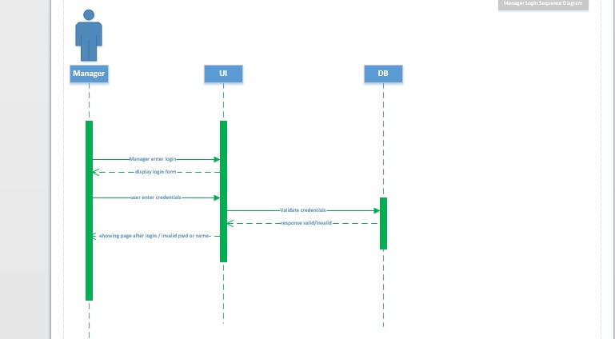

User Login SD

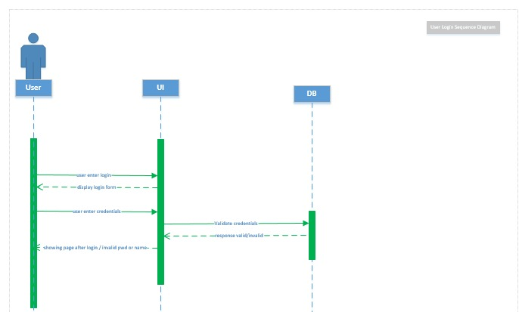

Change Parking Status SD

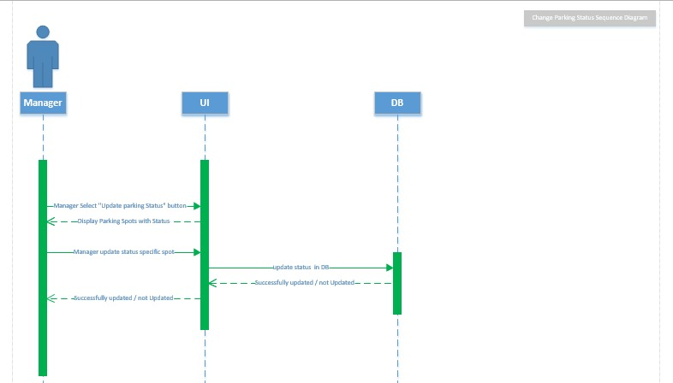

Manager Notify Users SD

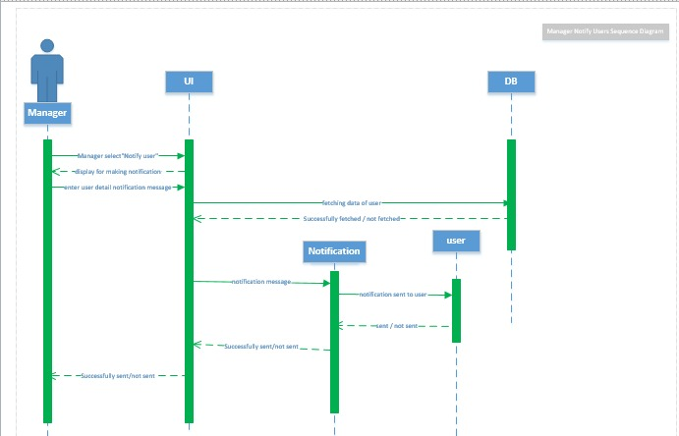

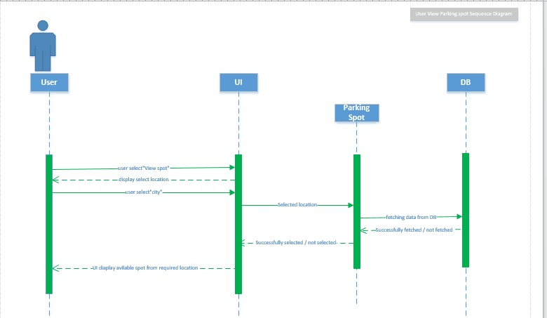User View Parking Spot SD

User Reserve Spot SD

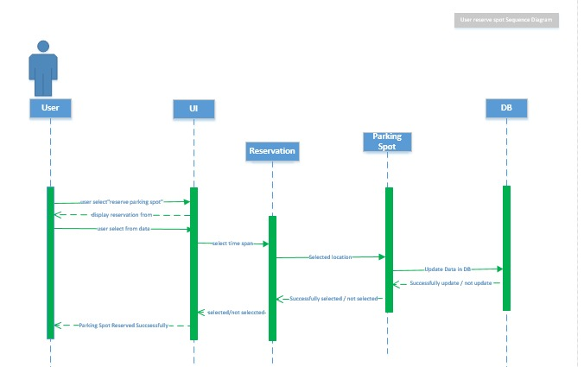

Payment SD

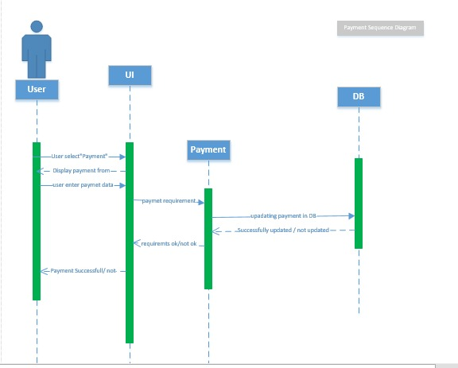

# **References**

R. S. Pressman, Software Engineering: A Practitioner’s Approach, 8th ed., McGraw-Hill

https://www.smartparking.com

**NOTE:**

1. References section should be on a last page.
2. The proposal should be prepared jointly by all the group members.